Customer details is missing. Below are the required fields.

ID, Customer Name, Contact, Company Name, Email, Details.**(DONE)(OK)**  
Eliminate delete option, Edit shall be inside the details menu, details shall be open in separate window.**(DONE)(OK)**

All customer shall be in one page not in multiple pages.

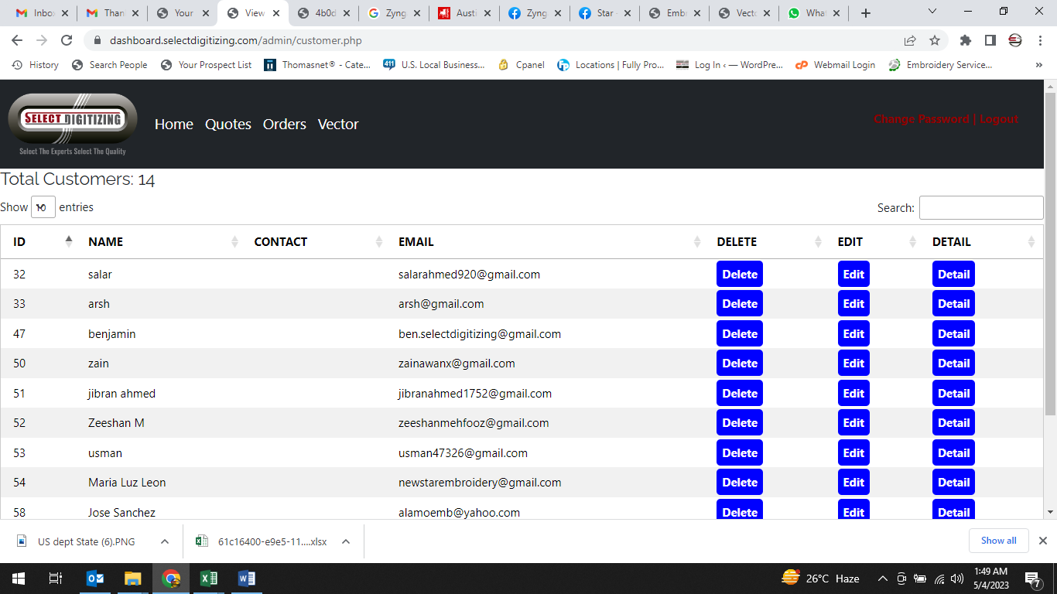

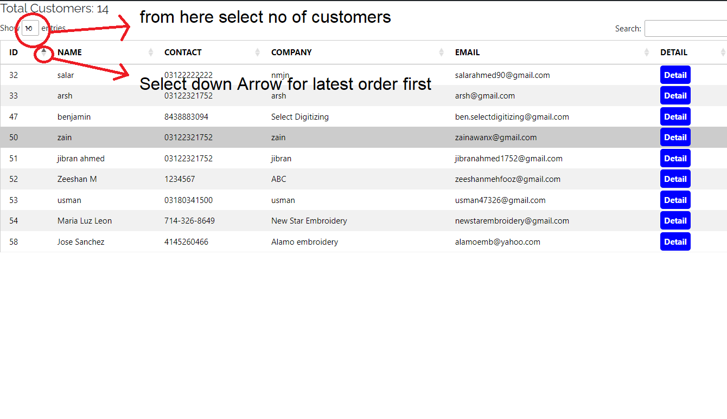

* Once we place quote, email subject shows QU-158 admin panel shows QU-1158. **(DONE)(OK)**
* Too many column in Total pending Quotes in admin panel.  
  Only required Quote ID, Design Name, Image, Date, Status, Release, PDF. **(DONE)(OK** But please ad customer id too in Pending quote, order & vector**)**

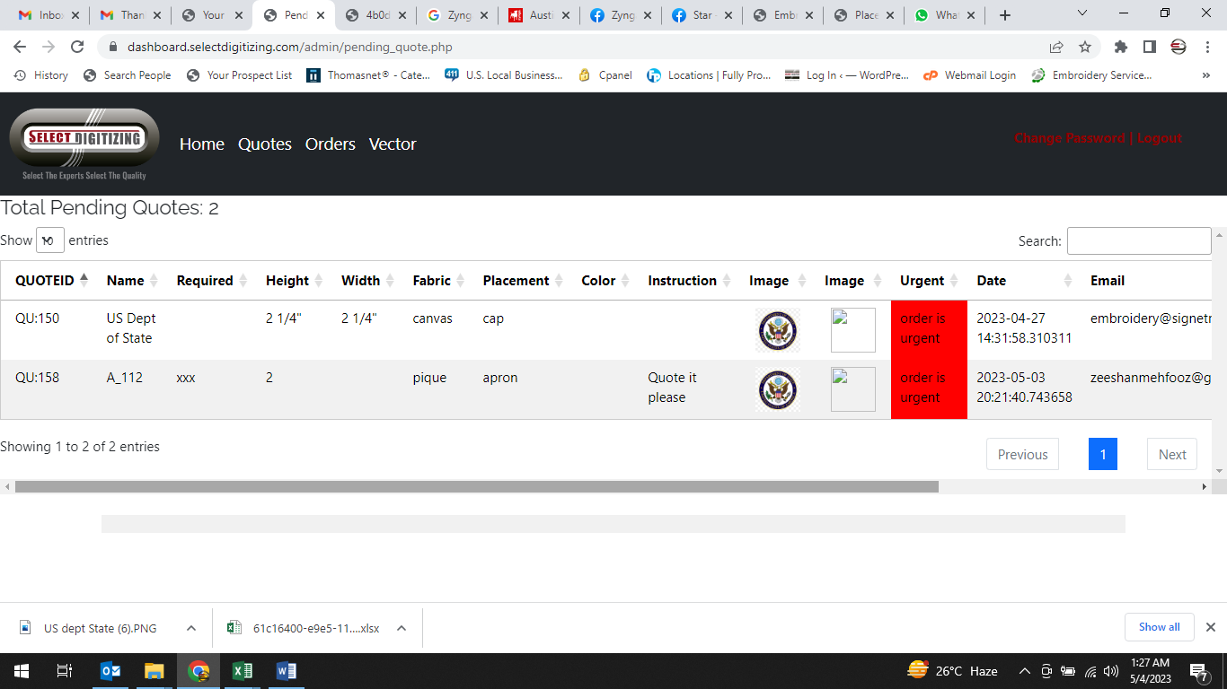

* When release order/quote/vector it jumps to record section, whereas it shall come back to “Total Pending Quote/Order/Vector”. **(DONE) (OK)**
* Add Edit & Convert to order in customer profile in detail section Quote record menu. **(DONE) (OK)**
* Quote edit not working. **(DONE) (Not Done, neither showing in admin panel nor in customer profile, no option to upload file and edit instructions box)**
* Apply LIFO method in quote, order & vector record in customer profile and admin panel too. **(DONE) (OK)**
* Order edit not working proper, no option to upload file and subject shall be OR-1143 R1 in second revision it should be OR-1143 R2, currently email subject show only OR-143. **(DONE) (Not Done, neither showing in admin panel nor in customer profile, no option to upload file and edit instructions box)**
* Edit orders is not reflecting in admin panel. **(DONE) (Not Done)**
* Vector Order placed but not reflecting in admin panel. **(DONE) (OK)**
* If wrong file attached in vector order error shall be in top instead at bottom. (allow all formats while placing the order)
* Edit not working in vector menu through customer profile. **(DONE) (Not Done, neither showing in admin panel nor in customer profile, no option to upload file and edit instructions box)**
* Invoicing option does not show vector order dates, also do not include quotes.

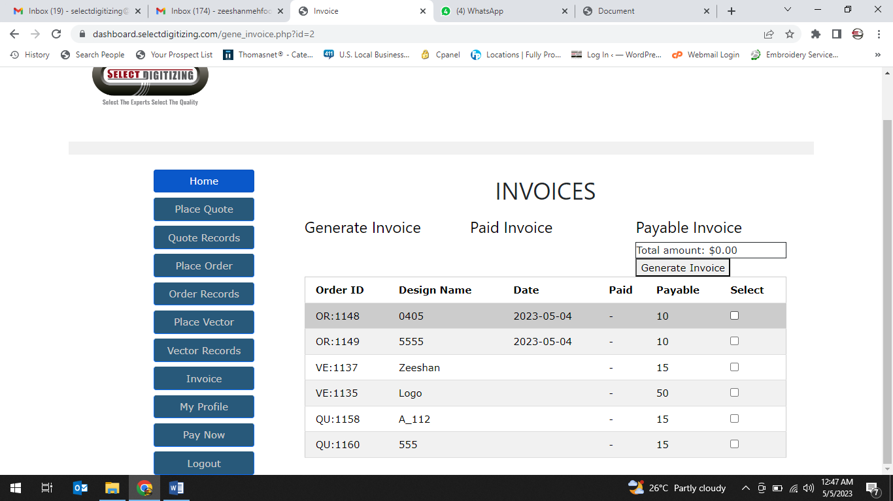

* Invoices menu need revision, it does not create invoice till selection of all orders. Also multiple invoices generated in Payable invoice for same amount.

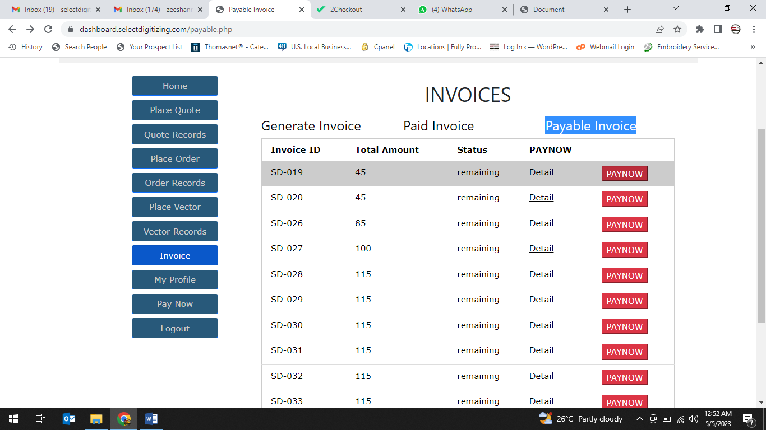

* Below 2 menus not working. Once I click on my profile it jumps to admin panel.

